EXPERIMENT 10:
PROGRAM CODE:

# ==============================================================
# REAL-TIME IoE STREAM ANALYTICS AND ANOMALY DETECTION
# Simulated MQTT + Node-RED pipeline for Google Colab
# ==============================================================

import numpy as np
import pandas as pd
import matplotlib.pyplot as plt
from IPython.display import display
from IPython.display import clear_output

np.random.seed(24)

print("=" * 85)
print("IoE STREAM ANALYTICS AND ANOMALY DETECTION SYSTEM")
print("=" * 85)

# --------------------------------------------------------------
# 1. GENERATE SENSOR DATA STREAM
# --------------------------------------------------------------
print("\n1. GENERATING IoE SENSOR DATA STREAM")

N = 600

timestamps = pd.date_range(
end=pd.Timestamp.now().floor("s"),
periods=N,
freq="s"
)

temperature = 28 + np.random.normal(0, 1.2, N)
vibration = 4 + np.random.normal(0, 0.6, N)
gas_level = 120 + np.random.normal(0, 8, N)

# Ground-truth anomaly labels: 0 = normal, 1 = anomaly
true_anomaly = np.zeros(N, dtype=int)

# Inject known abnormal events for evaluating detection.
anomaly_indices = np.array([80, 81, 82, 160, 161, 250, 251,
252, 350, 420, 421, 500, 501, 570])

for i in anomaly_indices:
true_anomaly[i] = 1

# Create different abnormal patterns.
for i in anomaly_indices:
if i % 3 == 0:
temperature[i] += np.random.uniform(9, 14)
elif i % 3 == 1:
vibration[i] += np.random.uniform(4, 7)
else:
gas_level[i] += np.random.uniform(45, 75)

df = pd.DataFrame({
"timestamp": timestamps,
"device_id": "IoE_SENSOR_01",
"temperature_C": np.round(temperature, 2),
"vibration_mm_s": np.round(vibration, 2),
"gas_level_ppm": np.round(gas_level, 2),
"actual_anomaly": true_anomaly
})

print("Total stream records:", len(df))
print("Injected anomaly records:", int(df["actual_anomaly"].sum()))
print("\nIncoming stream preview:")
display(df.head(10))

# --------------------------------------------------------------
# 2. MQTT MESSAGE SIMULATION
# --------------------------------------------------------------
print("\n" + "=" * 85)
print("2. MQTT MESSAGE INGESTION")
print("=" * 85)

mqtt_topics = [
"ioe/sensor/temperature",
"ioe/sensor/vibration",
"ioe/sensor/gas",
"ioe/alerts/anomaly"
]

print("Example MQTT topics:")
for topic in mqtt_topics:
print(" -", topic)

print("\nSample MQTT telemetry messages:")

for i in range(5):
row = df.iloc[i]
payload = {
"device_id": row["device_id"],
"timestamp": str(row["timestamp"]),
"temperature_C": row["temperature_C"],
"vibration_mm_s": row["vibration_mm_s"],
"gas_level_ppm": row["gas_level_ppm"]
}
print(f"Topic: ioe/sensor/telemetry | Payload: {payload}")

# --------------------------------------------------------------
# 3. NODE-RED-STYLE STREAM PROCESSING
# --------------------------------------------------------------
print("\n" + "=" * 85)
print("3. NODE-RED-STYLE PROCESSING PIPELINE")
print("=" * 85)

pipeline = [
("MQTT Input", "Receive sensor telemetry"),
("JSON Parser", "Extract sensor readings"),
("Function Node", "Check thresholds and abnormal patterns"),
("Switch Node", "Route normal and anomalous readings"),
("Alert Output", "Generate warning for abnormal readings"),
("Dashboard", "Visualize stream and anomaly alerts")
]

display(pd.DataFrame(pipeline, columns=["Node", "Function"]))

# --------------------------------------------------------------
# 4. STREAM ANALYTICS AND ANOMALY DETECTION
# --------------------------------------------------------------
print("\n" + "=" * 85)
print("4. ANOMALY DETECTION")
print("=" * 85)

# Example rules suitable for this simulated dataset.
# Thresholds are illustrative and should be calibrated for real sensors.
df["temp_flag"] = df["temperature_C"] > 34
df["vibration_flag"] = df["vibration_mm_s"] > 7
df["gas_flag"] = df["gas_level_ppm"] > 155

df["predicted_anomaly"] = (
df["temp_flag"] |
df["vibration_flag"] |
df["gas_flag"]
).astype(int)

df["status"] = np.where(
df["predicted_anomaly"] == 1,
"ANOMALY DETECTED",
"NORMAL"
)

alerts = df[df["predicted_anomaly"] == 1].copy()

print("Detected anomaly records:", len(alerts))
print("\nAlert examples:")

if len(alerts) > 0:
display(alerts[[
"timestamp", "temperature_C", "vibration_mm_s",
"gas_level_ppm", "status"
]].head(20))
else:
print("No anomalies detected.")

print("\nALERT GENERATION")
for _, row in alerts.head(10).iterrows():
reasons = []
if row["temp_flag"]:
reasons.append("High temperature")
if row["vibration_flag"]:
reasons.append("High vibration")
if row["gas_flag"]:
reasons.append("High gas level")

print(
f"[ALERT] {row['timestamp']} | "
f"Device: {row['device_id']} | "
f"Reason: {', '.join(reasons)}"
)

if len(alerts) > 10:
print(f"... and {len(alerts) - 10} additional alert records.")

# --------------------------------------------------------------
# 5. ANOMALY DETECTION PERFORMANCE METRICS
# --------------------------------------------------------------
print("\n" + "=" * 85)
print("5. ANOMALY DETECTION PERFORMANCE")
print("=" * 85)

actual = df["actual_anomaly"].to_numpy()
predicted = df["predicted_anomaly"].to_numpy()

TP = int(((actual == 1) & (predicted == 1)).sum())
TN = int(((actual == 0) & (predicted == 0)).sum())
FP = int(((actual == 0) & (predicted == 1)).sum())
FN = int(((actual == 1) & (predicted == 0)).sum())

accuracy = (TP + TN) / max(1, TP + TN + FP + FN)
precision = TP / max(1, TP + FP)
recall = TP / max(1, TP + FN)
f1 = 2 * precision * recall / max(1e-12, precision + recall)

metrics_df = pd.DataFrame({
"Metric": [
"True Positives (TP)",
"True Negatives (TN)",
"False Positives (FP)",
"False Negatives (FN)",
"Accuracy (%)",
"Precision (%)",
"Recall (%)",
"F1 Score (%)"
],
"Value": [
TP, TN, FP, FN,
round(accuracy * 100, 2),
round(precision * 100, 2),
round(recall * 100, 2),
round(f1 * 100, 2)
]
})

display(metrics_df)

# --------------------------------------------------------------
# 6. REAL-TIME-STYLE SENSOR STREAM PLOT
# --------------------------------------------------------------
print("\n" + "=" * 85)
print("6. SENSOR STREAM VISUALIZATION")
print("=" * 85)

fig, axes = plt.subplots(3, 1, figsize=(13, 10), sharex=True)

sensor_config = [
("temperature_C", "Temperature (°C)", 34),
("vibration_mm_s", "Vibration (mm/s)", 7),
("gas_level_ppm", "Gas Level (ppm)", 155)
]

for ax, (column, label, threshold) in zip(axes, sensor_config):
ax.plot(df["timestamp"], df[column], linewidth=1, label=label)
ax.axhline(
threshold, linestyle="--",
label=f"Alert threshold: {threshold}"
)

detected = df["predicted_anomaly"] == 1
ax.scatter(
df.loc[detected, "timestamp"],
df.loc[detected, column],
s=18, marker="x", label="Detected anomaly"
)

ax.set_ylabel(label)
ax.grid(True, alpha=0.3)
ax.legend(loc="upper left")

axes[-1].set_xlabel("Timestamp")
fig.suptitle("IoE Sensor Stream and Anomaly Alerts")
plt.xticks(rotation=25)
plt.tight_layout()
plt.show()

# --------------------------------------------------------------
# 7. CONFUSION MATRIX
# --------------------------------------------------------------
print("\n" + "=" * 85)
print("7. CONFUSION MATRIX")
print("=" * 85)

cm = np.array([[TN, FP], [FN, TP]])

plt.figure(figsize=(6, 5))
plt.imshow(cm, interpolation="nearest")
plt.title("Anomaly Detection Confusion Matrix")
plt.colorbar()

plt.xticks([0, 1], ["Predicted Normal", "Predicted Anomaly"])
plt.yticks([0, 1], ["Actual Normal", "Actual Anomaly"])

for i in range(2):
for j in range(2):
plt.text(
j, i, str(cm[i, j]),
ha="center", va="center", fontsize=14
)

plt.tight_layout()
plt.show()

# --------------------------------------------------------------
# 8. ALERT FREQUENCY
# --------------------------------------------------------------
print("\n" + "=" * 85)
print("8. ALERT FREQUENCY VISUALIZATION")
print("=" * 85)

df["time_window"] = df["timestamp"].dt.floor("min")
alerts_per_minute = (
df.groupby("time_window")["predicted_anomaly"]
.sum()
)

plt.figure(figsize=(12, 4))
plt.plot(
alerts_per_minute.index,
alerts_per_minute.values,
marker="o"
)
plt.title("Detected Anomalies per Minute")
plt.xlabel("Time")
plt.ylabel("Number of alerts")
plt.grid(True, alpha=0.3)
plt.xticks(rotation=25)
plt.tight_layout()
plt.show()

# --------------------------------------------------------------
# 9. SAVE RESULTS
# --------------------------------------------------------------
print("\n" + "=" * 85)
print("9. EXPORTING RESULTS")
print("=" * 85)

df.to_csv("/content/ioe_stream_results.csv", index=False)
alerts.to_csv("/content/ioe_anomaly_alerts.csv", index=False)
metrics_df.to_csv("/content/ioe_anomaly_metrics.csv", index=False)

print("Saved files:")
print("1. /content/ioe_stream_results.csv")
print("2. /content/ioe_anomaly_alerts.csv")
print("3. /content/ioe_anomaly_metrics.csv")

print("\n" + "=" * 85)
print("FINAL CONCLUSION")
print("=" * 85)
print("1. A simulated IoE sensor stream was generated.")
print("2. MQTT topics and example telemetry messages were displayed.")
print("3. Node-RED-style processing stages were demonstrated.")
print("4. Threshold-based anomaly detection generated alerts.")
print("5. Accuracy, precision, recall and F1 score were calculated.")
print("6. Sensor trends, anomalies, confusion matrix and alert frequency")
print(" were visualized.")
print("\nNOTE: This is a simulation, not a live MQTT or Node-RED deployment.")

OUTPUT:
=====================================================================================
IoE STREAM ANALYTICS AND ANOMALY DETECTION SYSTEM
=====================================================================================

1. GENERATING IoE SENSOR DATA STREAM
Total stream records: 600
Injected anomaly records: 14

Incoming stream preview:
 | timestamp | device_id | temperature_C | vibration_mm_s | gas_level_ppm | actual_anomaly
0 | 2026-10-20 08:01:05 | IoE_SENSOR_01 | 29.60 | 3.04 | 113.68 | 0
1 | 2026-10-20 08:01:06 | IoE_SENSOR_01 | 27.08 | 2.72 | 130.24 | 0
2 | 2026-10-20 08:01:07 | IoE_SENSOR_01 | 27.62 | 4.88 | 119.85 | 0
3 | 2026-10-20 08:01:08 | IoE_SENSOR_01 | 26.81 | 5.32 | 126.45 | 0
4 | 2026-10-20 08:01:09 | IoE_SENSOR_01 | 26.72 | 4.27 | 113.68 | 0
5 | 2026-10-20 08:01:10 | IoE_SENSOR_01 | 26.27 | 4.48 | 116.90 | 0
6 | 2026-10-20 08:01:11 | IoE_SENSOR_01 | 28.68 | 3.38 | 119.82 | 0
7 | 2026-10-20 08:01:12 | IoE_SENSOR_01 | 28.35 | 3.71 | 125.91 | 0
8 | 2026-10-20 08:01:13 | IoE_SENSOR_01 | 26.05 | 4.03 | 128.98 | 0
9 | 2026-10-20 08:01:14 | IoE_SENSOR_01 | 28.26 | 3.99 | 128.95 | 0

=====================================================================================
2. MQTT MESSAGE INGESTION
=====================================================================================
Example MQTT topics:
- ioe/sensor/temperature
- ioe/sensor/vibration
- ioe/sensor/gas
- ioe/alerts/anomaly

Sample MQTT telemetry messages:
Topic: ioe/sensor/telemetry | Payload: {'device_id': 'IoE_SENSOR_01', 'timestamp': '2026-10-20 08:01:05', 'temperature_C': np.float64(29.6), 'vibration_mm_s': np.float64(3.04), 'gas_level_ppm': np.float64(113.68)}
Topic: ioe/sensor/telemetry | Payload: {'device_id': 'IoE_SENSOR_01', 'timestamp': '2026-10-20 08:01:06', 'temperature_C': np.float64(27.08), 'vibration_mm_s': np.float64(2.72), 'gas_level_ppm': np.float64(130.24)}
Topic: ioe/sensor/telemetry | Payload: {'device_id': 'IoE_SENSOR_01', 'timestamp': '2026-10-20 08:01:07', 'temperature_C': np.float64(27.62), 'vibration_mm_s': np.float64(4.88), 'gas_level_ppm': np.float64(119.85)}
Topic: ioe/sensor/telemetry | Payload: {'device_id': 'IoE_SENSOR_01', 'timestamp': '2026-10-20 08:01:08', 'temperature_C': np.float64(26.81), 'vibration_mm_s': np.float64(5.32), 'gas_level_ppm': np.float64(126.45)}
Topic: ioe/sensor/telemetry | Payload: {'device_id': 'IoE_SENSOR_01', 'timestamp': '2026-10-20 08:01:09', 'temperature_C': np.float64(26.72), 'vibration_mm_s': np.float64(4.27), 'gas_level_ppm': np.float64(113.68)}

=====================================================================================
3. NODE-RED-STYLE PROCESSING PIPELINE
=====================================================================================
 | Node | Function
0 | MQTT Input | Receive sensor telemetry
1 | JSON Parser | Extract sensor readings
2 | Function Node | Check thresholds and abnormal patterns
3 | Switch Node | Route normal and anomalous readings
4 | Alert Output | Generate warning for abnormal readings
5 | Dashboard | Visualize stream and anomaly alerts

=====================================================================================
4. ANOMALY DETECTION
=====================================================================================
Detected anomaly records: 14

Alert examples:
 | timestamp | temperature_C | vibration_mm_s | gas_level_ppm | status
80 | 2026-10-20 08:02:25 | 26.04 | 3.59 | 171.11 | ANOMALY DETECTED
81 | 2026-10-20 08:02:26 | 41.14 | 3.87 | 117.74 | ANOMALY DETECTED
82 | 2026-10-20 08:02:27 | 27.80 | 10.06 | 111.75 | ANOMALY DETECTED
160 | 2026-10-20 08:03:45 | 26.90 | 7.18 | 121.14 | ANOMALY DETECTED
161 | 2026-10-20 08:03:46 | 29.20 | 4.26 | 158.06 | ANOMALY DETECTED
250 | 2026-10-20 08:05:15 | 28.38 | 7.67 | 127.13 | ANOMALY DETECTED
251 | 2026-10-20 08:05:16 | 29.18 | 2.96 | 179.92 | ANOMALY DETECTED
252 | 2026-10-20 08:05:17 | 38.36 | 4.21 | 118.27 | ANOMALY DETECTED
350 | 2026-10-20 08:06:55 | 28.05 | 4.03 | 184.29 | ANOMALY DETECTED
420 | 2026-10-20 08:08:05 | 36.93 | 3.30 | 109.31 | ANOMALY DETECTED
421 | 2026-10-20 08:08:06 | 27.85 | 9.82 | 119.70 | ANOMALY DETECTED
500 | 2026-10-20 08:09:25 | 27.67 | 4.68 | 160.43 | ANOMALY DETECTED
501 | 2026-10-20 08:09:26 | 41.07 | 3.96 | 127.19 | ANOMALY DETECTED
570 | 2026-10-20 08:10:35 | 36.26 | 4.58 | 124.92 | ANOMALY DETECTED

ALERT GENERATION
[ALERT] 2026-10-20 08:02:25 | Device: IoE_SENSOR_01 | Reason: High gas level
[ALERT] 2026-10-20 08:02:26 | Device: IoE_SENSOR_01 | Reason: High temperature
[ALERT] 2026-10-20 08:02:27 | Device: IoE_SENSOR_01 | Reason: High vibration
[ALERT] 2026-10-20 08:03:45 | Device: IoE_SENSOR_01 | Reason: High vibration
[ALERT] 2026-10-20 08:03:46 | Device: IoE_SENSOR_01 | Reason: High gas level
[ALERT] 2026-10-20 08:05:15 | Device: IoE_SENSOR_01 | Reason: High vibration
[ALERT] 2026-10-20 08:05:16 | Device: IoE_SENSOR_01 | Reason: High gas level
[ALERT] 2026-10-20 08:05:17 | Device: IoE_SENSOR_01 | Reason: High temperature
[ALERT] 2026-10-20 08:06:55 | Device: IoE_SENSOR_01 | Reason: High gas level
[ALERT] 2026-10-20 08:08:05 | Device: IoE_SENSOR_01 | Reason: High temperature
... and 4 additional alert records.

=====================================================================================
5. ANOMALY DETECTION PERFORMANCE
=====================================================================================
 | Metric | Value
0 | True Positives (TP) | 14.0
1 | True Negatives (TN) | 586.0
2 | False Positives (FP) | 0.0
3 | False Negatives (FN) | 0.0
4 | Accuracy (%) | 100.0
5 | Precision (%) | 100.0
6 | Recall (%) | 100.0
7 | F1 Score (%) | 100.0

=====================================================================================
6. SENSOR STREAM VISUALIZATION
=====================================================================================
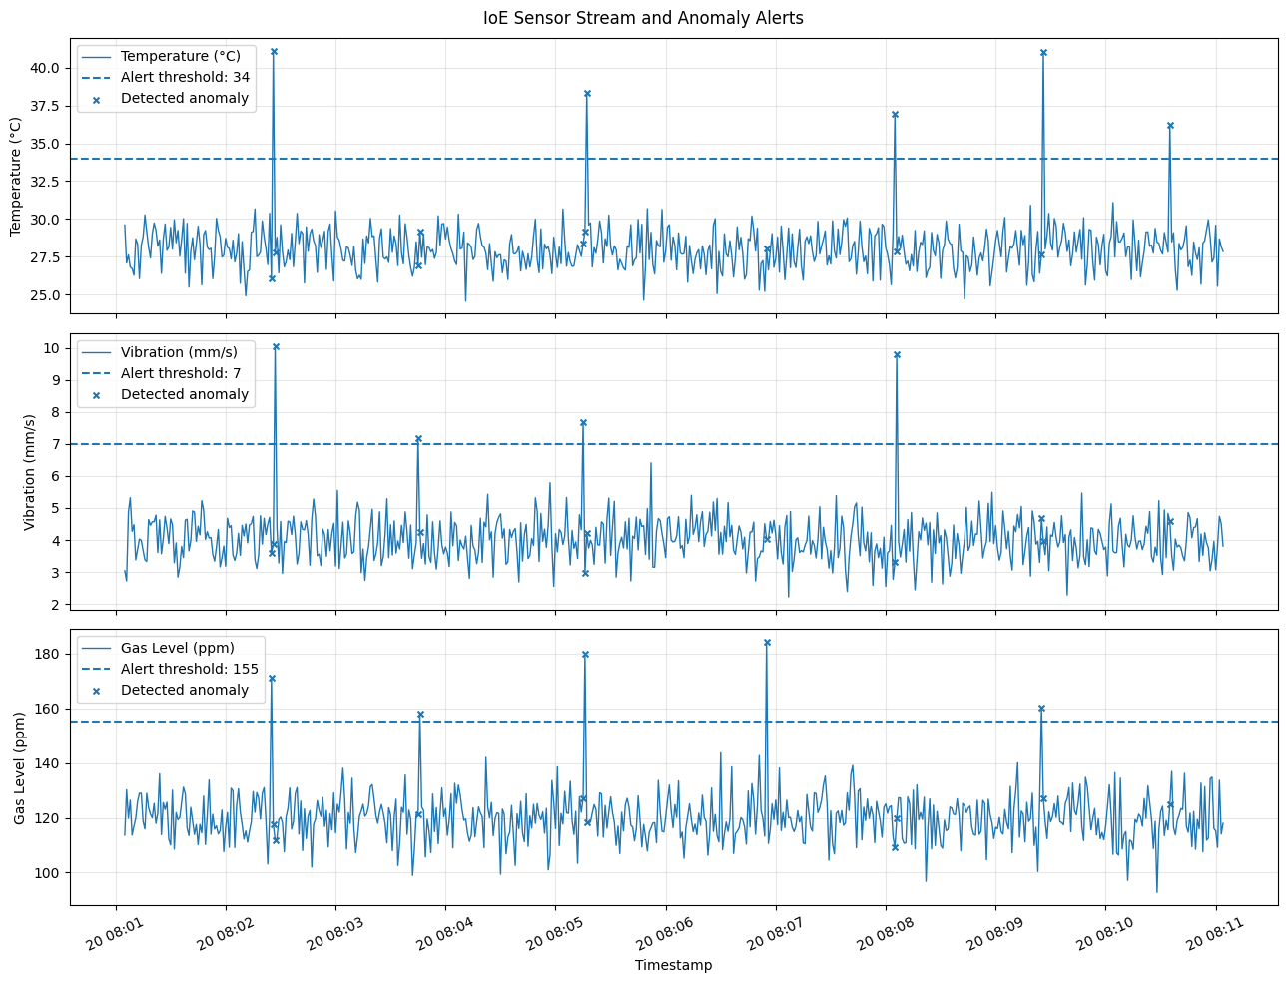

=====================================================================================
7. CONFUSION MATRIX
=====================================================================================
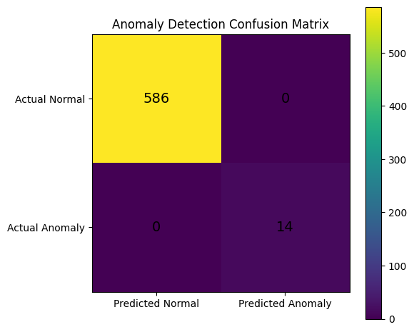

=====================================================================================
8. ALERT FREQUENCY VISUALIZATION
=====================================================================================
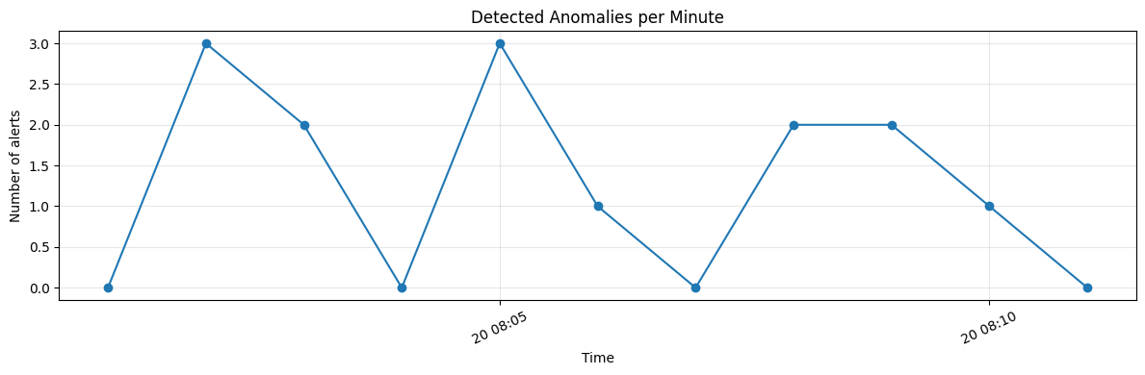
FINAL CONCLUSION
=====================================================================================
1. A simulated IoE sensor stream was generated.
2. MQTT topics and example telemetry messages were displayed.
3. Node-RED-style processing stages were demonstrated.
4. Threshold-based anomaly detection generated alerts.
5. Accuracy, precision, recall and F1 score were calculated.
6. Sensor trends, anomalies, confusion matrix and alert frequency
were visualized.

